A Research Report

On

**Tourism Prospects of Nepal**

**Theme: Responsible Tourism**

**Prepared By:**

**Nepal APF School Kirtipur, Kathmandu**

**Team members**

Bishesh Maharjan

Suyas Shrestha

Suraj Bista

Rupak Karki

Aashutosh K.C.

# Submitted to:

**Director -GTTP Nepal**

**10th Sept 2022 Kathmandu**

Table of Contents

* *INRODUCTION ON TOURISM ………………………………………………………………2*
* *INTRODUCTION OF NEPAL ………………………………………………………………...4*
* *TOURISM OF NEPAL ……………………………………………………………..5*
* *MAJOR ATTRACTIONS OF NEPAL (… WILDLIFE & NATURE IN… NEPAL*

*… THE FOOD IN NEPAL*

### *…CULTURE & SPIRITUALITY IN NEPAL)*

### *Impacts of covid …………………………………………………………………………..16*

* *TOURISM DEVELOPMENT INITIATIVES AND INSTITUTIONALIZATION IN NEPAL……………………………………………………………………………………17*
* *SUSTAINABLE TOURISM DEVELOPMENT………………………………………19*
* *DIAGNOSIS OF NEPALESE TOURISM MARKETING CONSTRAINTS ……..20*
* *NEPALESE TOURISM DEVELOPMENT PROSPECTIVE………………………21*
* *APPLICABILITY FOR NEPALESE TOURISM……………………………………24*
* *. NEPALESE TOURISM INDUSTRY DEVELOPMENT………………………….27*
* *. TRAVEL TIPS & RESOURCES……………………………………………………..29*
* *. CONCLUSION AND RECOMMENDATIONS……………………………………30*

*INTRODUCTION OF TOURISM*

*It is estimated that 21st century’s global economy will be driven by major service industries also called “3T” (Tourism, Technology (ICT) and Telecommunication). Travel & Tourism generated US$8.272 trillion (10.4% of total global GDP), 1.6 trillion of total exports (7% of world exports1) and 313.221 million jobs (1 in 10 jobs) for the global economy in 2017. Tourism is a multidimensional crucial development parameter of the world economy. Travel & Tourism impact on the economic, social-cultural, environment and political scenarios of the particular country. This overall comprehensive impact demonstrates the necessity of establishing public policy to guide, direct, co-ordinate and control the development of tourism in-order to minimize the negative impact and maximize the benefits. According to, Tourism Policy refers to an overall high level plan that includes goal and procedures; policies are generally found in formal statements such as laws and official documents and statements. Tourism policies are generally considered to be an area of nations overall economic policy, which is a public policy designed to achieve specific objectives relevant to tourism development of the country or region.*

*In tourism, public policies are related to co-ordination, planning, legislate, promotion, stimulation, allocate resources and solve the practical problems. Such policies are formalized for the development of plans, programs and agreements. In terms of tourism, public policies are aimed at growth of national income, generate employment, increase foreign exchange, ease for entrepreneurships, tourists to different areas (diversified development) enable spaces for tourism . In this stance more broadly defines that “Public policies on tourism are responsible for planning, development and promotion, while tourism marketing is responsible for attracting tourists to a destination, to develop new tourism products and services that meet tourists’ needs and satisfaction”. In the discourse of tourism marketing and innovation the government plays an important role along with private sector. Integrated actions and measures should be taken by both the public and the private sectors together in order to have common guidelines and strategies that meet the needs of both hosts and tourists. More broadly natural and cultural resources, tourism marketing, innovation, prices, quality, FDI, tourism policies and skilled human resources are the pillar elements of the tourism destination competitiveness; whereas the government is the single authority which owns the legislative power to influence positively. The following info graph (Figure 1) of the UNWTO shows the impetus of public sectors (government) interconnection towards course of tourism.*

**

*INTRODUCTION OF NEPAL*

*Nepal is the country which is unique on a number of levels, perhaps the most important being its sheer natural beauty, cultural diversity and religious shrine (Lumbini the birthplace of Lord Buddha, numbers of Hindus temple & pilgrimage sites). Country blessed with world’s highest mountain range; it containing eight of the world’s ten tallest mountains. Nepal is a magnet for the world’s most avid mountaineers, rock climbers, trekkers, and adventure seekers, owing to the immense vertical drop from its northern mountains to its southern plains containing hotspot for climatic and biological diversity. Naturally, cultural array mirrors of geological and climatic varieties, e.g. Chitwan National Park a World Heritage Site, lays more than 500 species of birds, 50 spp. mammals and 55 spp. amphibians reptiles. Sagarmatha National Park Its lowest point is approximately 2800 meters; is home to over 100 species of birds and provides universal scenic views of flora and fauna. Nepal’s biodiversity is not limited to land creatures. It is estimated that the country also has over 250 species of fishes in its vast river systems3. It also offers beautiful lakes, steep rivers and gorges, unique wildlife, historic monuments, impressive fine arts, significant religious sites and exotic cultures attracting a wide array of travelers for a variety of reasons. According to the recent report and prestigious travel portal of the world Nepal is one the top 10 country which receipts 24.9 percentages of international tourists arrival growth4 also featured on Forbes news. Which is satisfactory indicator for the nation, however this figure relating of natural growth proxy of above mentioned blessed tourism resources. Government need take all measure serious and apply adequate policy and initiatives towards tourism development, which can be obvious of game changer for Nepal i.e. policy and administration study are more significant in Nepalese tourism development context where almost most lack of evidence that high level academic research approach carried forward in this regard*

*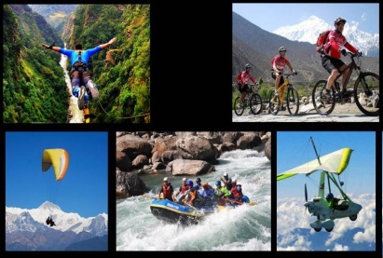*

***TOURISM OF NEPAL***

*Tourism is the largest industry in* [*Nepal*](https://en.wikipedia.org/wiki/Nepal) *and its largest source of* [*foreign exchange*](https://en.wikipedia.org/wiki/Foreign_exchange_market) *and revenue. Possessing eight of the ten highest mountains in the world, Nepal is a hot spot destination FOR mountaineers, rock climbers and people seeking adventure. The* [*Hindu*](https://en.wikipedia.org/wiki/Hindu) *and* [*Buddhist*](https://en.wikipedia.org/wiki/Buddhist) *heritage of Nepal and its cool weather are also strong attractions.*

***Major tourism attractions of Nepal***

*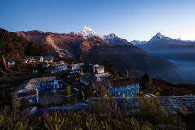*

*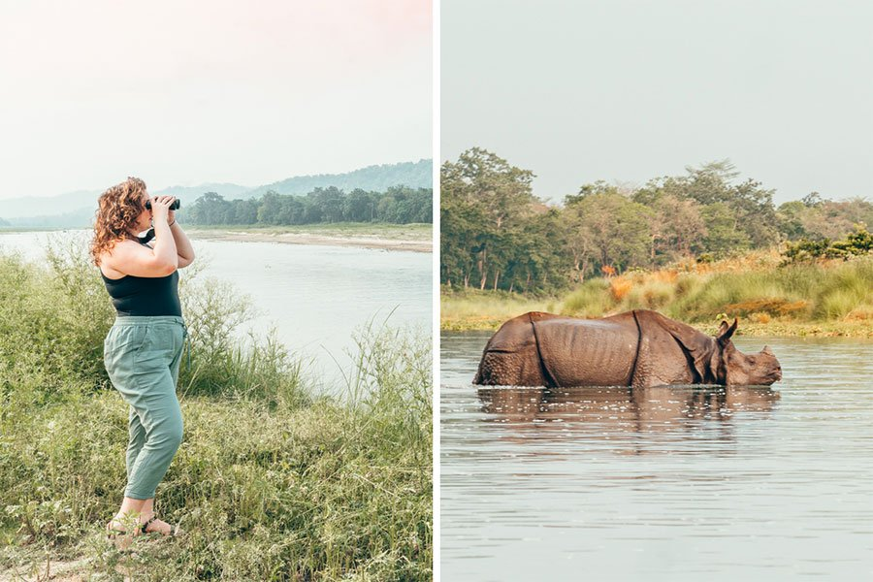*

*A one-horned rhino in Chitwan National Park!*

*… About Wildlife & Nature in Nepal*

*Nepal is very rich in wildlife diversity. There are unique animals to see and some of them are rare animals. Not only animals but also various species of birds are available here. Spiney Babbler is the bird that is only found in this country.*

*Here’s what you should know about Nepal’s wild side.*

*Nepal is a nature jackpot.*

*Nepal has it all, from icy tundra on the world’s highest peaks to exotic animals living in lush, tropical jungles. If you travel for scenery and wildlife, Nepal’s diversity is tough to beat!*

*Nepal has the highest peak and the deepest gorge.*

*And they’re both in the Himalayas! You’ve heard of Mount Everest, the tallest mountain on Earth, right?*

*Well, according to my Nepali guide,* [*Kali Gandaki Gorge*](https://en.wikipedia.org/wiki/Kali_Gandaki_Gorge) *is the deepest on Earth. According to Wikipedia, that claim is validated “if one measures the depth of a canyon by the difference between the river height and the heights of the highest peaks on either side.” That kind of feels like cheating, but ima let Nepal have this one.*

*At any rate, you can check it out yourself while trekking the Annapurna Circuit – you’ll pass right by it.*

*[10 Fascinating Places to Visit in Kathmandu, Nepal](https://practicalwanderlust.com/places-to-visit-in-kathmandu/" \t "_blank)*

***Swayambhunath temple***

***Pashupatinath temple***

***Booudhanath temple***

***Bhimsen tower***

***Chandragiri hill side***

***Basantapur tower***

***Budhanilkhantha***

***Thamel***

***Shivapuri nagarjun national park***

***Kathmandu darbar******square***

*Nepal is mostly mountains.*

[*According to research*](https://www.britannica.com/place/Nepal) *75% of Nepal consists of giant, majestic AF mountains. Those mountains are FULL of stunning treks, like the* [*Mohare Dande Trek*](https://www.twowanderingsoles.com/blog/mohare-danda-trekking-guide)*, which our friends from Two Wandering Soles hiked during their simultaneous trip to Nepal.*

*But don’t let all those mountains trick you into skipping the rest of the country! From the valleys of Kathmandu and Pokhara to the tropical lowlands of* [*Chitwan National Park*](https://www.chitwannationalpark.gov.np/)*, there is SO much else to see in Nepal.*

*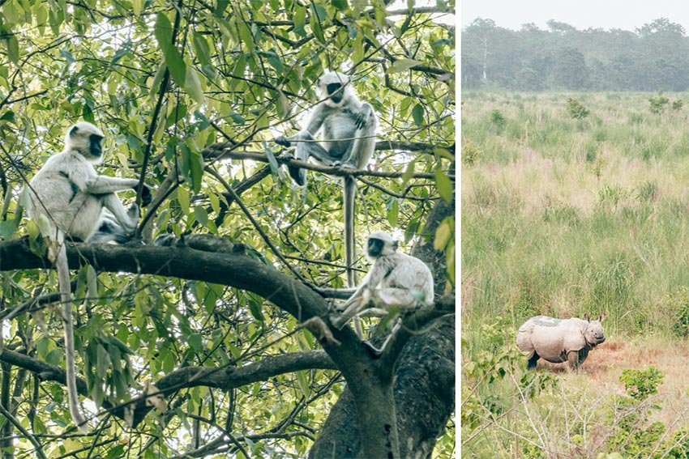cuddly monkeys and a smiling rhino in Chitwan National Park!*

*Nepal is home to a huge variety of wild animals!*

*Nepal has AMAZING wildlife diversity, and it’s home to a ton of adorable, fuzzy, cuddly animals (because all animals are adorable and fuzzy and cuddly. Yes, even the big scary angry scaly ones).*

*How much wildlife is there, you ask? Well, think of it this way: The Jungle Book was set next door, just a few hours away in Madhya Pradesh, India.*

*Here are some favorite Nepal residents:*

* *Bengal Tigers: Fierce, majestic kitty cats whose bellies I want to rub.*
* *Snow Leopards: Also fierce majestic kitties, but they like to play in the snow!!*
* *Red Pandas: The cutest animal in existence. It looks like a fox crossed with a panda and it’s freaking ADORBS.*
* *One-Horned Rhinos: Like big ol’ wrinkly hippos, but with giant horns. I saw FIFTEEN rhinos during my trip!*
* *Sloth Bears: Literally Balloo. Like, just big, derpy, slack-jawed bears.*
* *Marbled Cat: Looks exactly like a very fancy domestic cat. Like the kind of cat your cat would follow on Instagram.*
* *Elephants: Sensitive, sweet, intelligent chonks full of love and kindness (also: the most dangerous wild animal on this list.)*
* *Peacocks: Fabulous and dazzling, ’nuff said.*

*Obviously, you cannot actually touch, befriend, or get near any of them (and should run far away from anyone who tells you otherwise) but that doesn’t stop me from baby-talking to all of them in cutesy voices and falling in love with them from afar.*

*We can see rhinos and other animals bathing with families in the river, quite undisturbed by our boat silently floating by. Boars snuffling for food in the brush. A sloth bear huffalumping across the path. Monkeys playing overhead. Peacocks strutting along the riverbanks.*

*It was incredible.*

*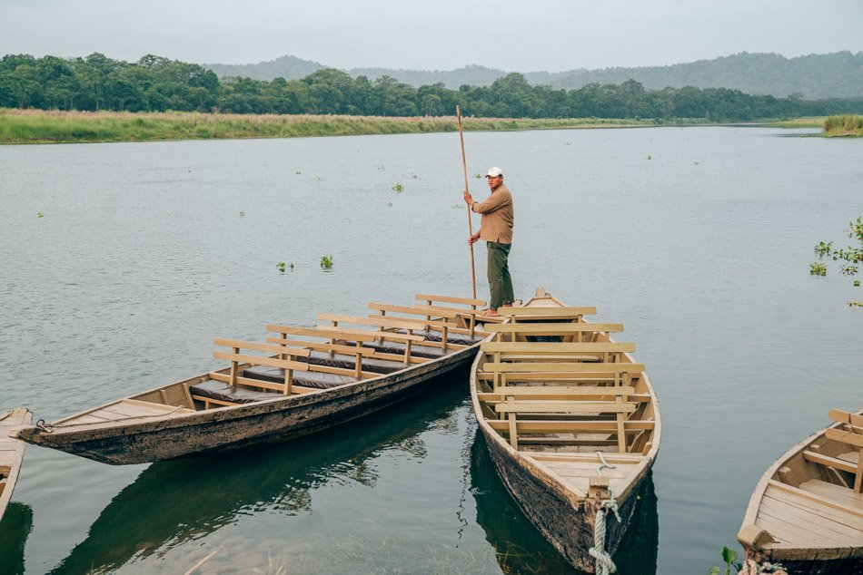*

*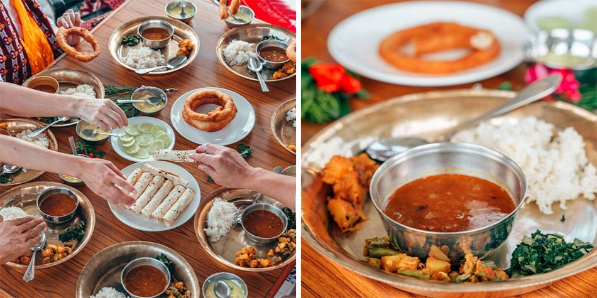*

***… About the Food in Nepal***

*Nepal’s food is a lot like Indian food, but … different.*

*There is a TON of Indian influence on Nepali food, which makes sense: after all, Nepal is bordered on 3 sides by India (and one side by Tibet, which we’ll get into in a momo-ent). You’ll also find tons of Indian snacks for sale in Nepali convenience stores.*

*But Nepali food is not the same as Indian food, and if you eat a lot of Indian food, this will be very apparent in ways that are hard to describe. While I’m not an expert in authentic Indian food, I have a LOT of feelings and opinions about Indian food in the USA, which I grew up eating. And Nepali food is just not quite like the Indian food that I know and love.*

*What’s different between Indian food and Nepali food, exactly? Is it the taste, color, or texture of familiar dishes? Honestly, yes – sometimes.*

*But overall, I think the main difference is the spices. Nepali dishes just don’t have as much spice as Indian dishes. And I’m not just talking about heat, here: I mean just like, in general. Nepali food sometimes left me wishing for spices that I don’t actually know the names of.*

*That’s not to say Nepali food isn’t good – because frankly, it’s still better than most of what I can get back home – it’s just… different.*

*Honestly? If you don’t eat a lot of Indian food, you probably won’t even notice.*

*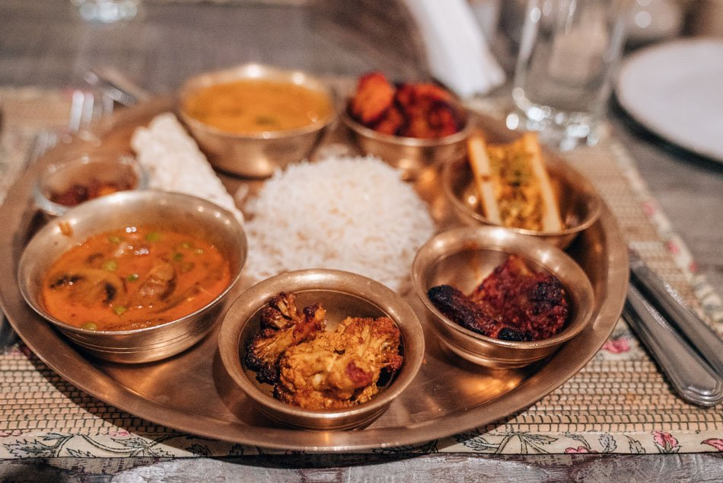*

*Dhal Bat is, essentially, curry and lentil soup plus a bunch of other stuff. It typically comes with rice and various sides. This was the best Dhal Bat of my trip, served at* [*Barahi Jungle Lodge*](https://practicalwanderlust.com/recommends/barahi-jungle-lodge/?label=traveling-in-nepal_amcid-3em3AVs3Ueiq7MFb7QIUr)*!*

*You’ll see “Dhal Bat” on every menu – it’s Nepal’s most common meal.*

*At it’s core, Dhal Bat is basically just some rice with a little bowl of lentil soup and, sometimes, chapati. But a typical dhal bat in Nepal usually comes with a wide variety of other vegetable side dishes in adorable little bowls.*

*You’ll typically order a dhal bat according to your preferred meat (or lack thereof) and then gratefully accept whatever side dishes it happens to be served with. Sometimes they’re amazing, like stewed eggplant or paneer curry or cauliflower and potatoes. Sometimes they’re insanely spicy (you might want to also order a mango lassi, just in case).*

*And sometimes they’re pickled bitter melon. I’m a fairly adventurous eater, but y’all … I do not like pickled bitter melon*

### *Culture & Spirituality in Nepal*

*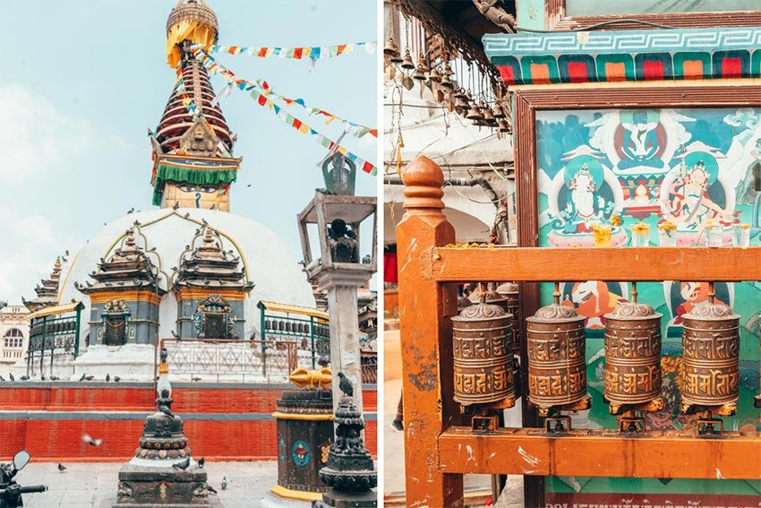*

*Nepal is a deeply spiritual country, something that I – as a not-spiritual person – didn’t expect to be quite so affected by.*

*But the spirituality in Nepal is an ever-present sensory experience: colorful prayer flags, chanting, ritual circling, the ringing of bells and shuffling of prayer wheels, the smells of incense and burning candles made from animal fat, groups of monks chatting (*and, in one case, texting, which made me do a double-take), *and temples in all sizes and shapes and colors. You can’t help but embrace Nepal’s deep spirituality!*

#### *Outside of the World Peace Pagoda in Lumbini and the Bodhisttva Siddhattha.*

#### *Nepal is the birthplace of Lord Buddha.*

*Yes, THE Buddha. His name was Siddartha, and he was born in* ***Lumbini****, Nepal sometime around 650 BC. His mother died shortly after childbirth, and Siddartha lived here in a small palace with his high caste Kshatriya Hindu family before deciding he didn’t want to live that privileged life and taking off on the journey that would eventually lead him to spiritual enlightenment*

#### *There are more than 120 different Indigenous Nationalities within Nepal.*

*Each has their own culture, language, and history, and together they make up a whopping 35% of Nepal’s population (*many claim it’s even more*).*

*However, like many Indigenous communities throughout the world* (including here in the USA)*, the Indigenous Nationalities of Nepal are marginalized and are fighting for rights and recognition from the Nepalese Governmen*

***Impact of covid in Nepal tourism***

***Tourism is one of Nepal’s largest industries. Tourism revenue in 2018 accounted for 7.9% of the country’s Gross Domestic Product (GDP) and supported >1.05 million jobs, with the expectation of providing >1.35 million jobs by 2029.***[***4***](javascript:;)***Nepal hosted 1.19 million foreign tourists in 2019, and the ‘Visit Nepal 2020’ campaign, officially introduced on 1 January, aimed to attract 2 million tourists, generate $2 billion and create thousands of new jobs.***

***However, on 23 January, the first case of imported COVID-19 was detected in Nepal. In response to cases worldwide increasing exponentially and amid growing public concern, the government suspended the ‘Visit Nepal 2020’ initiative on 3 March. Shortly after the World Health Organization (WHO) declared COVID-19 a pandemic on 13 March, the government suspended all permissions for mountaineering expeditions and suspended all visas.***

***Remittances from 3.5 million Nepalese living and working abroad account for almost a quarter of the country’s GDP. Since 2009, Nepal’s Department of Foreign Employment issued over 4 million permissions to migrant Nepalis working in 110 countries.***[***6***](javascript:;)***When the 2015 earthquake hit Nepal, foreign remittances jumped 20%, cushioning families against the financial shock of the disaster. COVID-19 is set to have a much worse economic impact than the earthquake and the migrant worker saviours have themselves become a problem. International flights are banned, keeping job-seekers at home and stranding migrant workers abroad. On 24 March, the government’s High-Level Coordination Committee for Prevention and Control of COVID-19 informed Nepalis abroad to remain where they were and appealed to host countries to offer them protection. Many have been laid off and are unable to return home. In some countries, migrant workers are still employed but the safety and health of all are jeopardized by the pandemic.***[***6***](javascript:;)***The government is currently investigating the repatriation of workers stranded in COVID-19 affected countries, even though this may place extra strain on the nation’s health system.***

***The pandemic has already challenged Nepal’s economy and the healthcare system. The resurgence of tourism may take longer than witnessed after the 2015 earthquake and remittances may not normalize soon. The government is taking steps to invest significantly in Nepal’s agricultural sector and is planning to incentivize migrant workers to stay and work in Nepal, as a means to boost the country’s economy in the long-term. The COVID-19 pandemic has sensitized the entire population as well as central and local authorities to the need for quality in healthcare. The government has increased the health sector budget to over 6% for the coming fiscal year, although this is still well below the recommendation of WHO (10%).***

***The pandemic necessitates long-term extreme measures to prevent healthcare facilities from being overwhelmed. The extent of the impact will depend on COVID-19 progression and the country’s ability to cope. Thus, there is a profound need for all stakeholders to take a far-sighted view and plan how best Nepal can, in the future, offer an appropriate and affordable healthcare service to its citizen***

*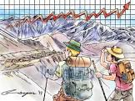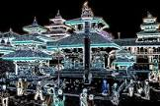*

***TOURISM DEVELOPMENT INITIATIVES AND INSTITUTIONALIZATION IN NEPAL***

*Tourism development has seen as dispersing geographically ever outwards from its origins in Britain and Western Europe, creating a series of “pleasure peripheries”, and spreading socially from the upper classes, down through the middle ranks and ultimately to the mass working classes . By the span of time tourism industry has spread the influence entire the world. Agents in this movement were social emulation, improvements in technology, awareness of education and accessible transportation. Nepal has been officially open for international tourism since 1951 and tourism sector today is an important employer and source of foreign currency generator5. However, the organized maiden tourism development planned initiative was taken place in only late 1972 A.D. along with drafting first Tourism master plan for the country. The first tourism master plan 1972 was drafted with the help of Germen tourism experts.*

*Nepal tourism master plan 1972 supplied the benchmark to access policy evaluation and project performance in tourism; conjunctive successive government of Nepal has been highly priorities the tourism sectors development; such as in 1998 GoN ministry of tourism celebrated “VSIT NEPAL YEAR” in order to promote Nepal tourism destination among international community, and also to encourage domestic tourism culture. 2011 remarked Nepal’s tourism year, aiming to promote and facilitate domestic and international tourism development. In-between there were noticeable historical tourism incidents recorded such as: in 1949 first foreigner Mr Bill came to Nepal for trekking, in 1950 first French summiteer team succeed Mount Annapurn (Fishtail), 1951 Nepal has been officially open for Foreign tourists and the same year first hotel opened in Kathmandu valley, in 1952 opening of first international hotel, in 1953 first Himalayan airways operated and Mr. Edmund Hillary and Tenzing Norgay Sherpa summited Mt Everest, in 1965 first trekking company established and in 1967 UN general secretary Mr U. Thant visited birth place of Buddha Lumbini, in 1972 tourism masterplan drafted, in 1978 first tourism act endorsed, in 1992 foreign aid and technology transferring act introduced, in 1993 aviation policy drafted, in 1995 first tourism policy endorsed, in 1996 civil aviation act endorsed also Nepal tourism board (NTB) act enforcement in the same year, in 2006 civil aviation policy and 2008 tourism policy of Nepal endorsed. Likewise formulation of tourism corporate association emerged in1966 HAN and NATTA, in 1972 NATHM, in 1979 TAAN and 1989 NARA*

*Ministry of tourism first came into the existence in 1978, in 1982 civil aviation was also merged into the ministry of tourism and it became the ministry of tourism and civil aviation. In 2000, cultural sector was also integrated in the ministry and called ministry of culture, tourism and civil aviation (MoCTCA)6. Ministry of culture, Tourism and civil Aviation acting in policy level, Department of tourism assisting to MoCTCA and acting as regulator and implementor. Nepal tourism board (NTB) solely authorized for promotion, marketing and branding Nepalese tourism destination among home and international arena (acting as regulatory and implementing level). Tourism sectors parallelly priorities by newly formulated federal governments (7 states in Nepal) by formulating ministry of industry, tourism, forestry and environment as a prominent federal cabinet ministry7.*

*Ministry of culture, tourism and civil aviation had lunched “TOURISM VISION 2020” in 2012. There are various tourism acts, policies, directives and rules are in legal effect such as tourism act 1978, the immigration act 1992, mountaineering expedition rules 2002, travel and trekking agency rule 2005, rafting rules 2006, hotel, lodge, restaurant, bar and tourist guide rule 1981, environment protection act 2007, tourism policy 2008 and tourism vision 2020 in 2012. Most importantly newly promulgated “Constitution of Nepal 2015” assimilated the tourism policy as one of the principal federal policy. Concurrent GoN declared 2020 as a “visit Nepal year once again from the cabinet decision with setup target of welcoming two million international tourists. In amidst of march 2018 MoCTCA has introduced and taken account 100 days action plan towards reviewing hampering tourism development policies and airport infrastructures also upgrading only one running international airport (TIA) of Nepal. There exist few other initiatives which is forwarded by GON under the framework of regional tourism co-operation and tourism infrastructure development project for example south Asian tourism infrastructure development project (SATIDP) between Nepal, India and Bangladesh which is primarily focused on developing sub-regional bilateral and multilateral tourism circuits whereas Nepal’s priorities should construct “Lord Buddha circuit”, which can be equally beneficial for the subcontinents as well as Tibetan plateau tourism development*

***SUSTAINABLE TOURISM DEVELOPMENT***

*.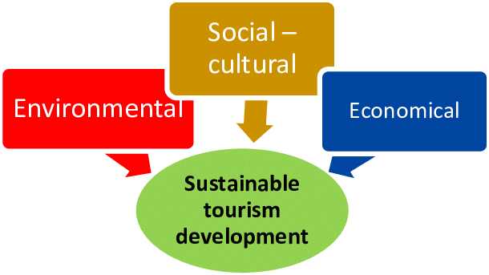*

*Sustainable tourism is defined by the UN Environment Program and UN World Tourism Organization as “tourism that takes full account of its current and future economic, social and environmental impacts, addressing the needs of visitors, the industry, the environment and host communities.Sustainable tourism is tourism development that avoids damage to the environment, economy and cultures of the locations where it takes place. The aim of sustainable tourism is to ensure that development is a positive experience for local people; tourism companies; and tourists themselves. Under sustainable tourism, it may be unlikely to experience the kind of 'boom and bust' that led to the rapid growth, and then despoliation of locations such as the east coast of Spain in the 1970s.*

*But how can sustainable tourism be achieved? Evidence suggests that it requires co-operation between concerned companies and the managers of destinations. It does not, however, require a marked interest from consumers. Some companies have suggested that they will only take steps to achieve sustainable tourism if they recognize a clear 'market demand' for holidays that are overtly 'green' or 'environmentally friendly'. Research, however, has indicated that few tourists want holidays that are 'green' within the mass tourism market; and that holidays that are 'green' may repeat the pitfalls of ecotourism. It may not be profitable or sustainable to encourage market demand for 'green' tourism as this demand may not occur, and also may not lead to sustainable tourism.*

***DIAGNOSIS OF NEPALESE TOURISM MARKETING CONSTRAINTS***

*Developing a tourism marketing assessment provides a model for understanding the nature of their tourism product, their tourism competitive market position and resident needs and concerns. It will help determine how to allocate scare resources in order to achieve specific economic development objectives. The term tourism promotion referred by defined term database “tourism promotion” means direct funding designated and spent solely for tourism, marketing of tourism or initiatives that, as determined in consultation with the local tourism industry organizations, attract travelers to the locality and generate tourism revenues in the locality. The role of Government involvement in tourism development and promotion always pays a vital role, as a public good, government’s tourism marketing plays an important role in promoting national tourism images and tourism destinations. Four main factors have significant effect on government’s tourism marketing, including motivation, market investigation capacity, synergy capacity of external network, and environmental policy interventions . However, promotion level of Nepalese tourist destinations is relatively low in terms of scientific and professional perspective, when comparing to other tourism destination countries. Therefore, it becomes a key issue to strengthen the scientific guidance of the government in tourism destination marketing and enhance the public marketing performance. The future for tourism marketing deems more exciting one, because of the technological and social changing phenomena are continually providing new opportunities and challenges. Therefore, the role of government institution dealing with tourism sectors is very crucial. According to the “Marketing is a subject of vital concern in travel and tourism because, in practical terms, it harnesses the power of massive commercial forces as well as government and regulatory influences” It is the principal management influence that can be used to shape the size and behavior of major growing global tourism market. Hence, we can generalize the terminology “tourism Promotion” also the integrated part of “Tourism Marketing"*

*Rapid changes in the competitive environment in the tourism have forced tourism destination to provide higher quality services and added the value to travelers Every tourism resource country willing to attract larger number of tourists, however achieving the target of receive larger number of targeted tourists inflows is a daunting task. Tourism marketing and promotion is the complex phenomena comparing with product marketing, it need a holistic approach to justify the weight of service marketing. Tourism marketing has become a strategy developed by various National Government, cities and region it increased the competitiveness and attract the target Tourist group .The phenomenon of the scientific tourism marketing by national institution has been common among developed countries, however less developed countries (e.g. Nepal) this is the quite new and more to achieve strategy. Recent year the technological tsunami bursting across the tourism industry and it will have profound implications on the travel experiences according to the earlier research by “tourism enterprises, distribution channels, governments, researchers and consumers are the key factors of Tourism market development”. He also stated that using of new information technology hold the power of fostering the global collaboration, co-operation and strategic alliances with in the tourism industry along new tremendous marketing opportunities*

***NEPALESE TOURISM DEVELOPMENT PROSPECTIVE***

*As aforementioned the Government of Nepal has been recognized tourism sector is one of the key industry with vast potentiality aiming to be the game changer of Nepalese sluggish Economy. In another hand GON had been engaged drafting tourism policies and programs since 1972. Currently there exist multiple institutional arrangement, e.g. Ministry of culture, Tourism and civil Aviation as policy and long-term strategies formation body, Department of tourism (DT) and Nepal Tourism Board (NTB), government regional tourism offices, newly formed federal tourism ministry as a regulatory, promotion and implementation body. However, the overall Nepalese Tourism development is lag-behind the viability. in-order to maximizing the tourism yield from the reserve possibilities of Nepalese Tourism resources, this paper aimed to scientifically explore & analyze tourism development, innovation and marketing practice as well as tourism polices drawbacks. To respond the current constraint of Nepalese tourism development and marketing planning very prestigious the SOSTACÒ marketing model deemed to very practical in order to capitalize the abundant tourism potentiality of Nepal. The SOSTACÒ marketing model was introduced by PR Smith in 1990, is a popular and widely used model for marketing communication and strategic planning. This model is impetus usefulness either overall marketing strategic setting or digital marketing strategy buildup, whereas the SOSTAC stands for situation analysis, objectives setting, strategy buildup, tactics finding, action plan and control mechanism respectively . This article centrally advocating the involvements of the Government institutions especially Nepalese case, the government solely can’t go for business as a private sector but government policy makers need to aware overall SOSTAC marketing communication strategy elements during their policy draft and promotional budgeting and implementing process.*

*As shown in Figure 2, SOSTACÒ diagram Nepalese tourism accountable authorities for promotional and marketing agents (NTB Nepalese Tourism Marketing and promotion agent) need to adopt scientific analysis and implementation of each elements of the model. There are many initiatives taken by Nepalese tourism development institutions (public and private), however there is always weak presentation of clear mission and vision, surficial analysis of situation, which is fundamental goal of success. This research also revealed from the key interviewee and document reviewed that there is unclarity of the objective formulation via tourism authorities such as core direction towards SMART and innovative.*

*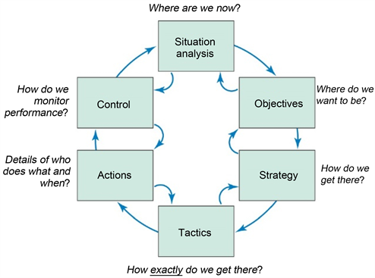*

*Source (PR Smith, 2005).*

*Traditional marketing and promotional strategy need to be replacing with scientifically approved and updated strategies such as introducing Nepalese contextual business model, segmentation of tourism market and priorities high yield target sources. likewise tactics should flexible with strategy and scientific, there is bitter truth in Nepalese tourism development major concern by respondents was action and control mechanism; lack of co-ordination between the major stake holders among internal and external tourism players, rigid assignment delivery accord to their personnel specialization, traditional and so called formality on control and tallying systems which is unavoidable for future planning and development of Overall tourism development of Nepal*

*.*

***APPLICABILITY FOR NEPALESE TOURISM***

*21st century global economy underwent strong technological changes moving towards IT-based flexible structures Much more innovation introducing in service sectors however especially third world countries like Nepal always remain lack of the benefits of tourism (service) innovation, in-order to enlarge market share and tourism product development. It is very important for policy maker to introduce and facilities tourism innovation in every step of the tourism development discourse to be successful in tourism development goal . Abernathy and Clark approach of innovation, scientifically transformed to the tourisms innovation by based on Original model explain that existing specific product or services innovations whether obsolete or entrenchment in the current time, in some cases old ideas and qualifications become outdated and need to be replaced, while other cases development of existing structures are more relevant. In short, this model illustrates four types of innovations: Regular, Niche, Revolutionary and Architectural innovations.*

*Regular innovation: regular innovation can help economies the existing technology and market. The scale of regular innovation adoption leads the dramatical changes on advancing the existing quality, improving the tourism features and removing the bottlenecks. In the Nepalese tourism industry regular innovativeness can acquired through Promoting new investments that raise productivity, Training proprietors and staff to operate more efficiently and Incremental raise of quality and standards.*

*NICHE innovation: in tourism NICHE innovation refers to introducing new tourism product increments towards existing market and new markets segments as well. Countries like Nepal there are abundant possibility applying NICHE tourism products. The management must nurture quick footed capability to promote the entry of new entrepreneurs to exploit business opportunities, encourage tourism, firms to enter new marketing alliances and combine existing products in new ways in order to strive maximum profit.*

*Architectural innovation: according to the http://provenmodels.com/ description the use of new concepts in technology to forge new market linkages forms the essence behind architectural innovation. New technology that departs from established systems of production and, in turn, opens up new linkages to markets and users, is characteristic of the creation of new industries as well as the reformation of old ones.*

*Revolutionary innovation: Innovation of this sort defines the basic configuration of product and process and establishes the technical and marketing agendas that will guide subsequent development. The policy makers of Nepalese tourism development need constantly scan the technological development on the tourism ecosystem, create the new events and attractions that demand a reorganization, redefining the physical or legal infrastructure in order to unmet the market needs. In a line this model highly beneficial for developing countries because of innovation deficits (radical change), so that at same time continually and carefully introduced incremental innovation (changes) which is very basic for Nepalese tourism industry development.*

*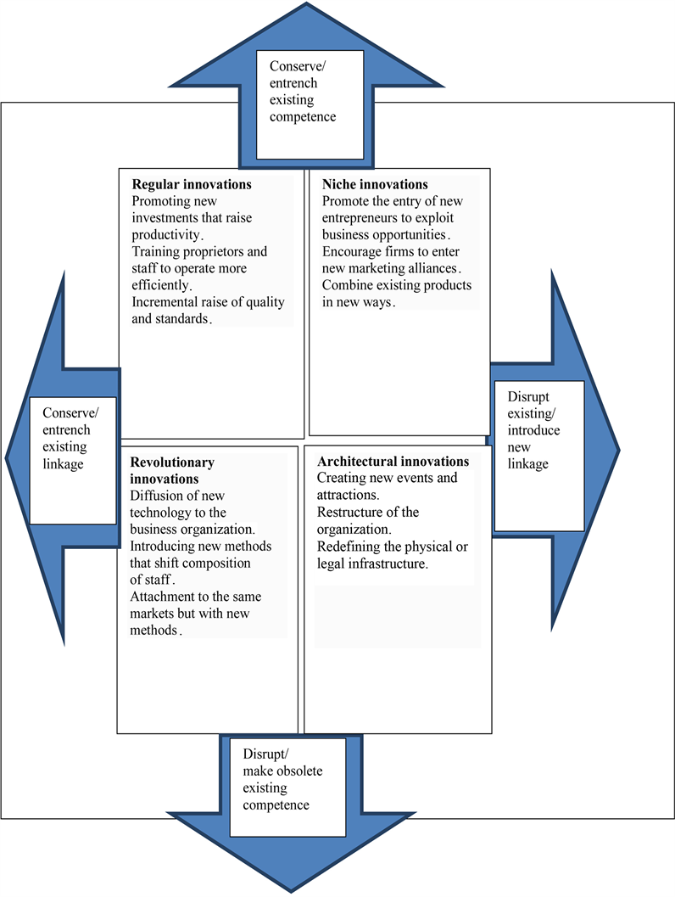*

***NEPALESE TOURISM INDUSTRY DEVELOPMENT***

*Many well-known and highly expertise theory some case cannot be consent and applicable for different political and geographical scenarios. After discussing above presented two prestigious models and in addition of gathered information from this research, I’d like to purposed forward following sketched generalized model for Nepalese tourism development which can be consider very practical and contextual for Nepalese tourism industry scenario. As shown in* [*Figure 4*](https://www.scirp.org/journal/paperinformation.aspx?paperid=90864#f4)*. The terminology of my sketched model phase-I shows IPO (input, process and output) model with appendage of Evaluation in every steps of the tourism development discourse. As a inputs policy should be daft with clear mission and smart vision, as a process innovative actions need taken towards implementing activities, output should tallying with expected outcome and regular evaluation need in every steps. Evaluation must be flexible and contextual so that can amend in time and switching to another better alternative.*

*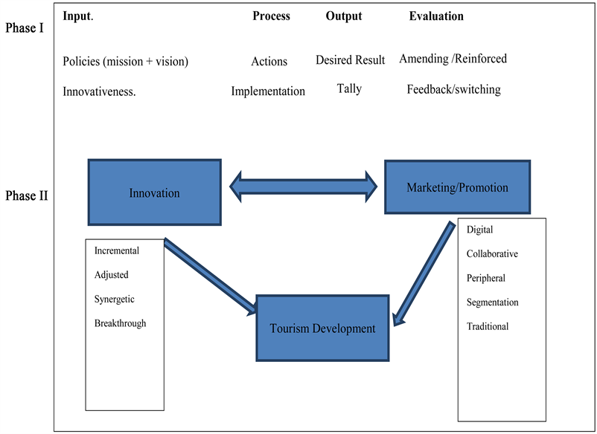*

*For the Nepalese tourism (most of developing countries) development context the fundamental hindrance is deficits of budget line for introducing new technology, miss-management of available resources, weak tourism infrastructure and improper tourism marketing techniques. Taking account these pitfalls of the tourism development innovation management should priorities and implement Incremental, adjusted, Synergetic and Breakthrough (i.e. incremental: regular increments, adjusted: flexible upon the situation, synergetic: applying the innovation which can have multiplier positive effects, Breakthrough: create own technology which can be novel either modified) approach of steps respectively.*

#### *OUR TOP TRAVEL TIPS & RESOURCES*

*Here are our favorite travel tips & resources for saving money and planning travel logistics! For more tips, check out* [*our travel tips resource page*](https://practicalwanderlust.com/travel-tips/) *or our* [*guide to planning a trip*](https://practicalwanderlust.com/how-to-plan-a-trip-travel-planning-tips/)*.*

* ***Booking Flights****: To score flight deals, search on Google Flights or* [***Kayak***](https://www.anrdoezrs.net/links/8242832/type/dlg/sid/travelinginnepal_amcid-z6b7JMPFZzIZmAeQ3QqFO/https:/www.kayak.com/flights)*. Money-saving tips: fly mid-week or on the weekend; fly carry-on only on a budget airline; and take red-eyes or early morning flights.*
* ***Accommodations:*** *We usually stay in budget-friendly vacation rentals, boutique hotels or private rooms in hostels. We use* [***Booking.com***](https://www.booking.com/index.html?aid=1321795&label=traveling-in-nepal_amcid-AeJbEOMYxVlBBV6pZeUgO)*to book hotels (*we love their flexible cancellation policy*) and* [***Hostelworld***](https://hostelworld.prf.hn/click/camref:1011lII8/pubref:ResourceBox/ar:ResourceBox/%5bp_id:1100l15345%5d) *to book hostels (*low deposit, easy change/cancellation, and excellent reviews)*. For vacation rentals, we prefer to book using* [***VRBO***](https://practicalwanderlust.com/recommends/vrbo-2/) *because they've got lower fees and better support than Airbnb, and we're not fans of Airbnb's unethical track record. You can also book vacation rentals on* [***Expedia***](https://practicalwanderlust.com/recommends/expedia-vacation-rentals/) *and* [***Hotels.com***](https://practicalwanderlust.com/recommends/hotels-com-vacation-rentals/)*. We also use* [***TrustedHousesitters***](http://tidd.ly/b850bfaf) *as both hosts (for our home and our fur-child) and travelers!*
* ***Travel Insurance:*** *We always, always, ALWAYS buy travel insurance for international trips, and we STRONGLY suggest it - visit our* [*Travel Insurance Guide*](https://practicalwanderlust.com/is-travel-insurance-worth-it/) *to find out why. We recommend either* [*World Nomads*](https://www.worldnomads.com/travel-insurance?affiliate=prctclwndr&subId=&utm_source=prctclwndr&utm_medium=affiliate&utm_campaign=Affiliate&utm_content=link) *or* [*SafetyWing*](https://safetywing.com/a/practicalwanderlust) *for international travel insurance. SafetyWing is one of the few policies that covers Covid-19, and they have excellent monthly policies that are perfect for Digital Nomads and long term travelers!*
* ***Travel Credit Card:*** *We book all of our trips on our favorite travel credit card. Not only do we earn cash back that we can spend on more travel, but the card offers fantastic travel perks like travel insurance, trip delay and cancellation coverage, lost baggage reimbursement, and rental car coverage, which helps protect us on our travels.* [*Learn more here.*](https://practicalwanderlust.com/best-credit-card-for-international-travel/)
* ***Vaccines & Meds:*** *We use the travel guides on the*[***CDC website***](https://wwwnc.cdc.gov/travel/destinations/list/) *to research recommended medications and vaccines for international trips. We always recommend getting every vaccine recommended by the CDC! You can get them at your primary care doctor's office or a walk-in pharmacy.*
* ***Tours:*** *We love booking guided tours, especially food tours and walking tours, to get a local's perspective and a history lesson while sight-seeing! We book our tours using* [***Viator***](https://www.viator.com/?pid=P00038815&mcid=42383&medium=link&campaign=traveling-in-nepal_amcid-Bb3l7qlgYYrzoNNePoAis) *and* [***GetYourGuide***](https://getyourguide.com?partner_id=6LSTX00&utm_medium=online_publisher&utm_source=practical_wanderlust&placement=content-end)*.*
* ***Transportation****: We use* [***Rome2Rio***](https://www.rome2rio.com/) *to figure out how to get from place to place, and book local transportation online using* [***Bookaway***](https://www.bookaway.com/?offer_id=34&aff_id=1864) *wherever we can. When we book a rental car, we use* [***Kayak***](https://www.anrdoezrs.net/links/8242832/type/dlg/sid/travelinginnepal_amcid-NZEm6mQV2bQV2OiPbUizI/https:/www.kayak.com/cars) *to compare rental companies and find the best deal.*
* ***Luggage Storage:*** *Whenever we're checking out early or taking advantage of a long layover, we use* [*LuggageHero*](https://luggagehero.go2cloud.org/aff_c?offer_id=54&aff_id=1119) *to safely store our luggage while we're running around. Use the code PRACTICALW for 2 hours of free luggage storage on us.*
* ***VPN Service:*** *A VPN keeps your digital information (like website login details, bank info, etc) safe, even when you're connected to an unsecured network while traveling. Plus, it lets you use Netflix & other streaming sites abroad! We use* [*NordVPN*](https://practicalwanderlust.com/recommends/nordvpn/)*. Use the code WANDERLUSTPROMO when you sign up!*
* ***What to Pack:***[*Here are the travel essentials*](https://practicalwanderlust.com/ultimate-packing-list-must-have-travel-items/) *that we bring on every trip. We also have packing lists for* [*hot weather*](https://practicalwanderlust.com/backpacking-travel-essentials-hot-climates/)*,* [*cold weather*](https://practicalwanderlust.com/cold-weather-travel-winter-packing-list/)*, and many more. Take a look at* [*all of our packing guides*](https://practicalwanderlust.com/packing-lists)*!*

***CONCLUSION AND RECOMMENDATIONS***

*Tourism development discourse is critical and multifaceted that requires an interdisciplinary and integrated approach, which must be supplemented by continuous and systematic research in to all aspects of tourism. Fundamentally, “Innovation and Marketing” are the two key factors for tourism success in the 21st century For a developing nation, it is a daunting task to make a new technology or upgrade an existing technology because of deficits of finance and lack of skilled manpower The small scale of incremental innovation and readiness of transferring innovative marketing technology can lead to a big positive change on tourism development for developing countries. Nepal is a true symbol for the high competitive and diversified tourism destination of the world for adventure seekers. The outreach and gross receipts for the tourism industry in Nepal are negligible in spite of the high potentiality of high-end tourism yield. Taking reference from matrix contents and applied for Nepalese tourism industry development the major findings are presented.*

*presented Nepalese tourism developmental major constraints results (finding) of this research work provided strong evidence that Nepalese tourism development discourse seeks multiple integrated assignments in order to yield from tourism sectors, improved and competitive tourism industry equally impetus for overall Nepalese economy rejuvenation. Hence, there is a necessity of policies and actions, ambidexterity towards branding, marketing, innovation, focused programs, improvement of business investment, human resource development, infrastructures development, improvement of tourism quality, reforms of institutional set-up & management, conservation of cultural heritage and zero carbon target . This research equally vows that there is miserable situation of ground transportations and aviation infrastructures in Nepal .*

*Based on this research finding, we like to suggest that: policies towards mountaineering and adventurous tourism should upgrade and regulate effectively, innovate the tourism attraction, amenities, accessibility and pricing, at the same time digitize the promotional techniques (ICT-focused), activate tourism council towards functionality, redefine FDI on tourism enterprises, update and implement advanced tourism technologies, encourage skill development and provide incentives towards tourism business for youths, increase the channels of co-operation and collaboration mode of tourism promotion campaign, facilitate the tourism research and measure the result with better implementation, “emphasize the e-WOM (online world of Mouth) platforms which is psychologically important for Place attachments” [*[*49*](https://www.scirp.org/journal/paperinformation.aspx?paperid=90864#ref49)*] , introduce novel seeking adventurous niche destination, encourage collaboration with multinational tour operators, (big size OTA, TMC, DMC, MICE, car-sharing and NTO’s), regularize organizing international events, upgrade modern looking multilingual website, promote and facilitate online booking and payment, take advantage of Search Engine Optimization (SEO), promote natural healing tourism, pay more focus on INDO-CHINA+ASEAN tourism resource market, extend marketing activities in to more geographic potential source market, support aviation modernization and route development, target high performing client segments, improve quality (QAS), expand commercial and G2G partnership and strategic partnership, unified strategic priority should have carried forward along industry, government body and corporate partners, stimulate the investment on tourism sectors by commercial banks, improving and expanding the connectivity and destination infrastructures, uplift the public private partnership with community involvement, prioritized tourists security and safety measures and perseveres of natural, cultural and heritage, improve dissemination of tourism information, encourage domestic tourism by means of incentives, improving reception facilities, ease and waive the acquisition of visa policy and enriching the tourist content of the Global influential media, promoting tourism investment fund, establish NTB’s overseas offices and nominate marketing representatives in various parts of the world, encourage Nepalese diaspora for tourism contribution, host trip for international celebrities, implement tourism satellite system, being alert on immediate update and renewal available tourism infrastructures. Nepal planning commission should draft and prioritize long-term tourism infrastructures, bring the incentives towards attracting offseason tourists, well management of Nepal national flag carrier, policy should prioritize the night-hour tourism, e.g. especial tourism zone 24/7 business hour with government full security, build the fast tract co-ordination mechanism of government tourism institution (national-regional-provincial-local level government) etc. in a line integrated tourism model, and policies, plan and actions should be directed towards sustainability, innovativeness and accessibility. The existence of big knowledge gap will lure the academia and research community towards high level of pragmatic and quantitative research to solve the Nepalese tourism developmental constraints*